Car Availability

Car availability can be set by location, by car group by date and by 19 up to time periods per day. A suspend on car availability will override any availability that is set on AVLBLORU. To process an availability change, the /FOR B601 signing the terminal in at the fleet owner level must be completed. In addition, there is also security processing, which requires the use of a PIN number to process an availability change. Availability can be set and displayed for a maximum of 365 days.

Screen Description and Functions:

The /FOR STDBAVL screen will allow for updating of car availability statuses. There are five different actions that can be used on this screen depending upon the type of availability update that is being processed. The dates used for updating availability can start with today’s date, and end one year later minus 2 days. Availability is always kept for the previous day due to time zone differences, and for a maximum of 365 days in total. The following is a review of the screen prompts and associated entries.
- Agent ID: The 5 character agent id must be entered.
- PIN: The PIN number associated to the entered agent id is required. Only agent ids with PIN numbers allowing access to availability updates can process a change. The PIN administrator established Pin’s that allow this access, and the PIN must be updated every 45 days.
- Actions: The following are the valid entries:
  - STD – This action will update the status for a block of time each day for a specific range of dates. For example, the C car group can be suspended from noon to 1PM for October 1st through October 15th using this action. (See example 1)
  - LOC – This action will update the status for every time slot from the effective time on the effective date through termination time on the termination date. For example, the D car group can be suspended from 3PM on October 10th through 12 noon on October 13th using this action. (See example 2)
  - GEO - This action will update the status for any or all of the 9 geographic bands for the range of dates specified in the effective date and termination date. For example, all car groups can be suspended for geographic band 9 for December 21st through December 31st using this action. (See example 3)
  - DEF – This will update the default availability segment for one year into the future. This represents the basic starting point for car availability for a location. The terminal must be signed into the fleet owner to perform this action. The DEF is actually placed in the Effective date, and the action STD is used.
    - Station: This transaction will accept either one rental station number or one hierarchy station that represents multiple rental stations. As previously stated, the terminal performing the update must be signed in as the fleet owner, for the locations being updated. If the location being updated is a hierarchy station number, the system will reprompt with a message, indicating the hierarchy, and the number of locations that will be updated. If the information is correct, the user should respond with a “Y” to the “ARE YOU SURE” question to continue to process the transaction. (See example 7)
    - Group: A single letter representing each car group(s) to be updated can be entered, up to a maximum of 15 car groups, or a “Y” can be entered to process all 16 car groups. A “Y” cannot be combined with the entry of a single car group, and must be placed in the first car group slot.
    - Effective Date: The date must be formatted as DDMMMYY. This is the start date for the availability being updated. The effective date is required for all actions.
    - Termination Date: The date must be formatted as DDMMMYY. This is the start date for the availability being updated. The effective date is required for all actions.
    - Status: There are 5 possible status types that can be entered:
- A = Available
- L = Default to local availability (can only be used with action GEO)
- S = Suspend
- R = Request
- T = Tour rates only (can only be used with action GEO), and is used in conjunction with the “Inbound Tour Rate” indicator on the rate as stored on the rates data base. The indicator on rates database must be set to a “Y” to have the availability available, if it is set to “N” then the availability will be suspended.
  - Effective Time: This entry is required for actions STD and LOC.
The time should be entered in military time format.
  - Termination Time: This entry is required for actions STD and LOC. The time should be in military time format.
NOTE: There are 19 time periods allocated for each day, the first time period is from 00:00 through 05:59, and the remainder of the day is broken out by hour. This break down limits the capability to change availability from midnight to 6 AM to require an availability update to cover this entire time period, and is not allowed by the hour.
  - Zone: This field has nine positions to enter the availability status for any of the geographic bands, 1 through 9 where an availability change is required. This field should only be entered for action GEO.

Example 1:
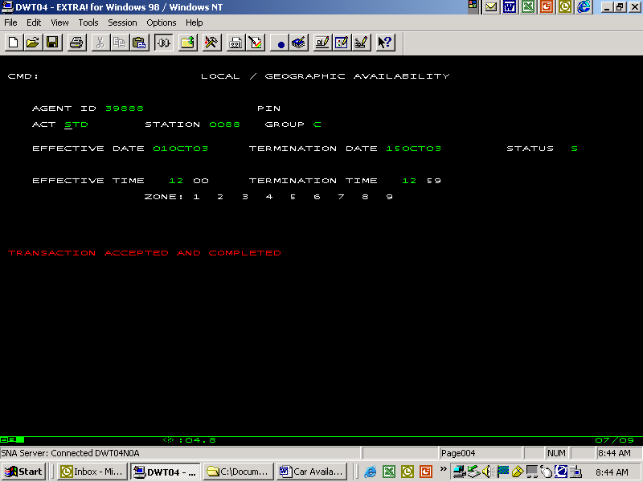

Example 2:
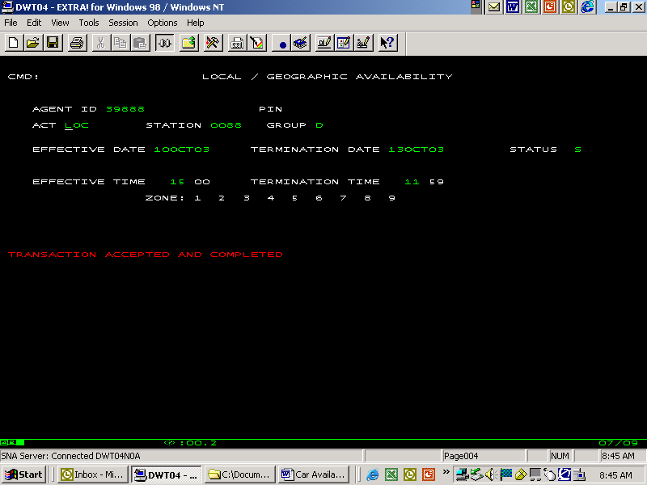

Example 3:
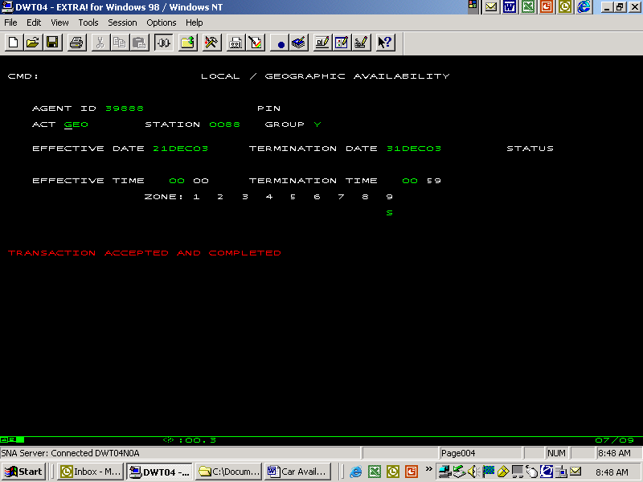

Example 4:

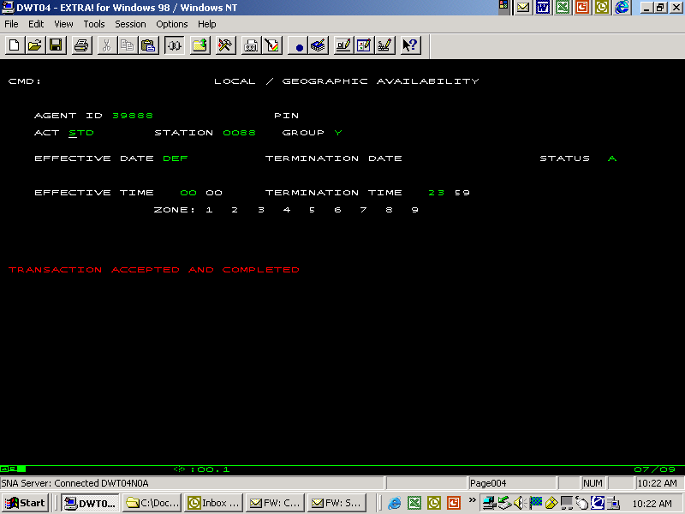

Example 5:

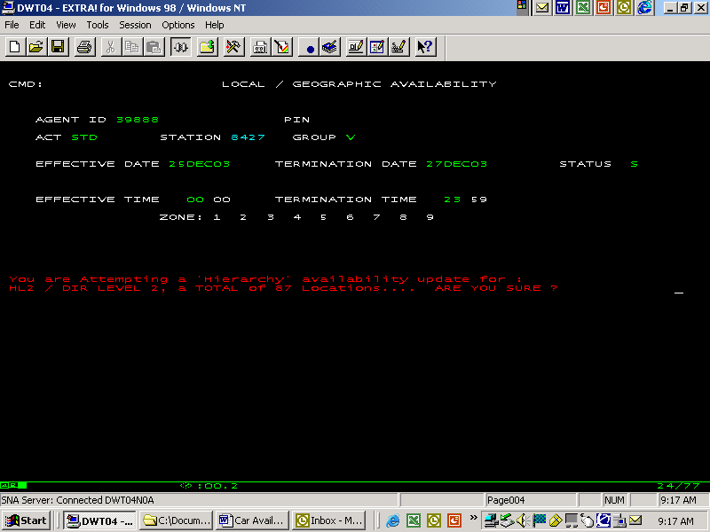

Vehicle Availability by
Length of Rental

The Availability by Length of Rental System (AVLBLORU) is a means to control the availability of certain car groups based on the length of time requested for a particular reservation. This means that with this system, it is possible to deny shorter rentals in favor of longer duration rentals. If for example two reservations for the same date, location and car group are requested for a Wednesday, it would be possible to deny the one day reservation, but accept the two day reservation. The intent of the system is to maximize the use of the vehicles during high demand periods.

The AVLBLORU system allows for the entry or modification of up to one month of availability data for up to 16 car groups for up to 20 individual rental stations, or a single hierarchy station number. The AVLBLORU system works in on a “change data only” basis. This means that first a display for a station must be completed before the LOR data on the screen can be updated. All changes to the data will be applied to all car groups and all stations specified.

AVLBLORU works in conjunction with standard availability (STDBAVL). As previously stated, standard availability is based on 19 time periods. AVLBLORU overlays the 19 time periods on standard availability with the LOR status only when the status on STDBAVL reflects “A”, or available. LOR status can be set as:
- S = Suspend
- A =Available
- M =Morning suspend
- E = Evening suspend
If the LOR status is morning, then the time periods up to (but not including) the PM suspend time for that station are set to suspend. If the LOR status is evening, then all time periods after (and including) the PM suspend time are set to suspend.

Originally when updates were made to the AVLBLORU screen, vehicle status messages were sent to the GDS. The vehicle status messages that were sent to the GDS contained the date that the control was to apply, but did not contain any length of rental guidelines, since the GDS are not able to handle this type of availability. As a result, if AVLBLORU contained a length of rental suspend of 1 to 4 days for a specific date and car group, a vehicle status message of “request/need” was sent to the GDS. This meant that any non seamless travel agent requests for a date that had an LOR restriction in place would show all Avis rates as being on “request/need” status. Travel agents could not differentiate a “request/need” status based on LOR from one in place by the STDBAVL system. Travel agents are less likely to book Avis, since there is a process in place that allows a location 48 hours to either confirm or deny a request reservation before the system automatically denies the reservation. Even though car types on request due to LOR reservations would process immediately, travel agents did not know this.

To handle the above situation, a link was created between AVLBLORU and the Rate Availability System (RAV). This link provides a method to send rate inventory messages to the GDS when LOR restrictions are in place. This provides the travel agent with a more accurate picture of Avis availability for non-seamless transaction, and it also appears in the data transmitted from Galileo for use with AROS. Based on the plan type of the rate and LOR’s closed, either a close or request status message is sent to the GDS. A close status is sent to the GDS if all relevant LOR’s are suspended, otherwise a “request/need” status for that rate, car group, location and date is sent. Any LOR’s that are closed by AVLBLORU will be carried forward to the LOR’s on RAV system. If any LOR’s are reopened on AVLBLORU the updates are also carried forward to the RAV system. The following are the status codes that can appear on RAV as length restrictions:

A = available on both RAV and AVLBLORU
- S = suspended on RAV
- B = suspended on both rate inventory and AVLBLORU
- L = LOR restrictions are in place on AVLBLORU for that length

The following is the relationship between LOR’s on AVLBLORU and inventory messages sent to the GDS.
  - Length of rentals 1 through 4 is used to determine status for daily and weekend rates. If all four lengths are closed, then a close status message for ALL daily and weekend rates is sent to the GDS. (All daily and weekend rates refer to any rate on rates data base that has the GDS indicator set to “Y” and is defined by GDS rate updating rules as a daily or weekend rates. This update is not limited to rate codes that appear in the RAV system.) If any of the four lengths are closed, but not all, then a “request/need” status message for ALL daily and weekend rates is sent to the GDS.
  - Length of rentals 5 through 27 is used to determine status for weekly rates. If all lengths are closed, then a closed message for ALL weekly rates is sent to the GDS. (All weekly rates refer to any rate on rates data base that has the GDS indicator set to “Y” and is defined by GDS rate updating rules as a weekly rate. This update is not limited to rate codes that appear in the RAV system.) If any of the 5 through 27-day lengths is closed, but not all, then a “request/need” status message for ALL weekly rates is sent to the GDS.
  - Length of rental 28+ is used to determine the status for monthly rates. If the 28+ length is closed, then a close for ALL monthly rates is sent to the GDS. (All monthly rates refer to any rate on rates data base that has the GDS indicator set to “Y” and is defined by GDS rate updating rules as a monthly rate. This update is not limited to rate codes that appear in the RAV system.)
NOTE: If the vehicle is on “hard suspend” through the use of /FOR STDBAVL, and an update is made on AVLBLORU or RAV to suspend additional lengths of rentals, or to close a rate product, no updates will be sent to the GDS since the overall car availability overrides any rate level availability. If the “hard suspend” is removed, the system will then send an available for car type, and then send availability message for the appropriate rate codes.

Three screens also exist for verifying the last status message that has been sent to the GDS from standard availability, AVLBLORU and RAV. These screens are:
- /FOR STDSTATS – Vehicle Availability
- /FOR RAVSTATS – Display Screen For Last Status Sent
- /FOR AVLSTATS – AVLSTATS – Display the Last AVL Status Sent

Overview of screens:
- /FOR STDSATS – This screen allows the user to view a location’s car availability by car type for an entire month. The screen shows the availability for all 19-time periods. Updates made on AVLBLORU are not reflected on this display. The screen input requirements are as follows:
  - Action – The only action accepted in DIS
      - Date – The date format is MMMYYYY. This is the month that the data is desired for.
  - Car Class – The single letter representing the car group to be displayed.
  - Station – The 4 character rental station number is entered.
See example 1 for a sample of the screen.
    - /FOR RAVSTATS – This screen allows the user to view the last rate availability message that was sent to the GDS for a specific location, rate code, car group for a specific month. The data will be displayed by date, and by plan type daily, weekly, weekend and monthly. The screen input requirements are as follows:
      - Action – The only action accepted is DIS.
      - Date: The date format is MMMYYYY. This is the month that the data is desired for.
  - Car Group - The single letter representing the car group to be displayed.
  - Rate Code – The rate code for which the availability data is requested.
  - Station – The 4 character station number for the location, which the data is being requested for.
See example 2 for a sample of the screen.
    - /FOR AVLSTATS – This screen allows the user to display what car availability message would have been sent to the GDS with the old car availability message based on changes made via AVLBLORU. The screen input requirements are as follows:
- Action - The only action accepted is DIS.
- Date: The date format is MMMYYYY. This is the month that the data is desired for.
- Station – The 4 character station number for the location, which the data is being requested for.
See example 3 for a sample of the screen.

Screen Description and Functions:

AVLBLORU processing creates length of rental updates by station, date and car group. The AVLBLORU system allows for the addition or modification of up to one month of availability data for up to 16 car groups for up to 20 individual rental stations, or a single hierarchy station number. To display AVLBLORU data, the /FOR AVLBLORU screen can be used, but if updates are required, the /FOR AVLBLORU screen must be used. The following is a review of the screen prompts and associated entries.
    - Action – There are three actions valid action responses, DIS for display, ADD for add and UPD for updating. A display must always be performed prior to an add or update. A display will show availability for both local return and the 9 geographic bands.
    - Date – The format for the date is MMMYYYY. This entry is for the month of data to be reviewed or updated.
    - Car Group(s) – The single letter representing the car group to be displayed/updated is entered. Up to 16 car groups can be updated
    - Station(s) – A 4 digit rental number must be used for the display, but an update or add can be processed by up to 20 rental locations or one hierarchy number.
See example 4 for a sample of the screen.

Note: The yield model recommendations when processed will create updates to the AVLBLORU system. Generally manual updates are not made to this database.

The Supply and Demand System, which is used to allow or deny reservations based on the supply of vehicles available, has also been integrated into the AVLBLORU system. At this time the Supply and Demand System is not in use. If this system is used, 4 new status codes could appear on the AVLBLORU screen, but cannot be entered on the screen. These codes are:
- L = suspended by supply, no manually entered suspends
- B = suspended by supply and an all day suspend on AVLBLORU is in place.
- P = suspended by supply and an PM suspend is in place on AVLBLORU
- O = suspended by supply and a AM suspend is in place on AVLBLORU

Example 1:

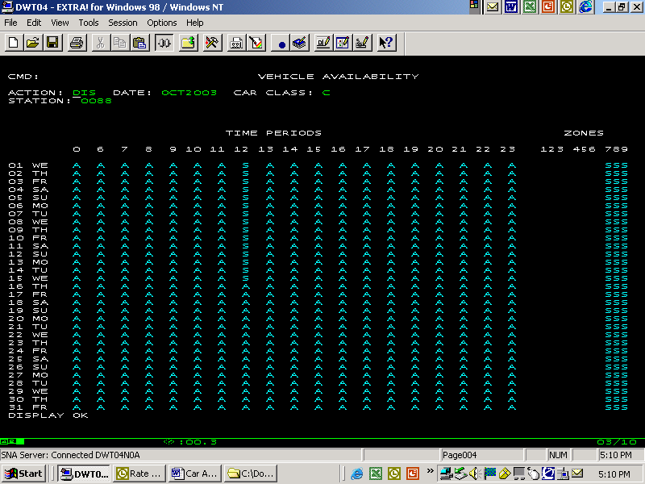

Example 2:

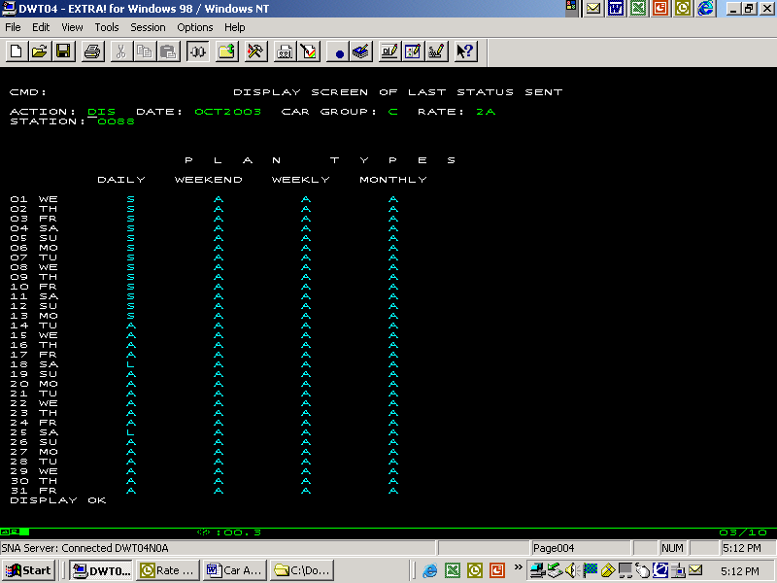

Example 3:

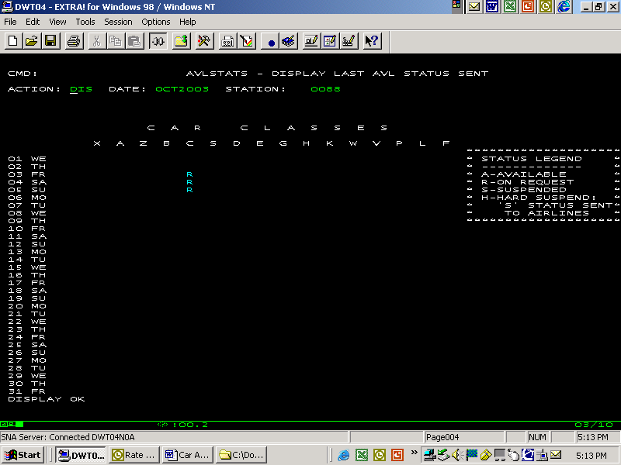

Example 4:

